HORMISDALLEN SCHOOL - KYEBANDO

PRE-PLE SET 1 EXAMINATION, 2023

PRIMARY SEVEN MATH

Duration: 2 Hours 15 Minutes

**NAME: ______________________________________________ STREAM: _____________**

EMIS NO.

INDEX NO.

**SECTION A (40 MARKS)**

Questions 1 to 20 carry two marks each

1. Add: 123 + 24

2. Work out: +6 + -2

3. Simplify:

4. Solve for **m : m ÷ 3 = 18**

5. Write 39 in Roman numerals.

6. Given that a = 2 and b = -1, find the value of a2 – b2.

7. Study the Venn diagram below and find the n(Q – P).

Q

P

6 1

3 8 10

4 9

8. The probability of picking a boy to be the class captain is 0.25; find the probability of picking a girl.

9. Find the value of h in the diagram below:

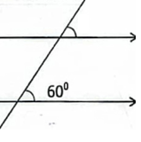

**h+200**

10. Write 3600 in standard form.

11. Decrease sh.6000 by 5%

12. Using a ruler, a pencil and a pair of compasses, draw a perpendicular line from point **P** to meet line segment **LM** at **X**.

13. Use the distributive property to work out: (37.25 x 8) – (17.25 x 8)

14. Express 0.5454…..as a simplified common fraction.

15. The diagram below is a semi-circle. Find its perimeter. (take 𝞹 = )

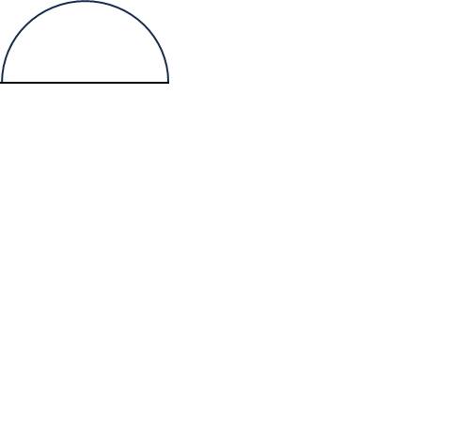

**14 cm**

16. A bus left Kampala at 8:00a.m and reached Iganga at 10:30a.m covering a distance of 120 km. At what speed was it moving?

17. There were $\frac{1}{5}$ fewer females than males in a meeting attended by 30 males. How many people attended that meeting?

18. Plot T(0,-3) on the grid below.

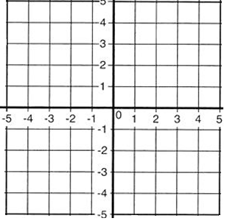

19. The mean mark scored by 5 pupils in a test was 52. If the marks were 48, 54, 66, **k** and 70, find the value of k.

20. Find the value of **p** in the sequence below: 1, 3, 6, 11, (p+7).

**SECTION B (60 MARKS)**

21. Study the Venn diagram below showing pupils who prefer maths (**M**) and English (**E**) in a class.

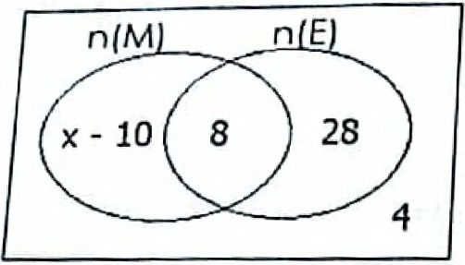

1. If 20 pupils prefer maths (**M**) only, find the value of x. (2 marks)

(b) How many pupils like either Mathematics or English? **(2 marks)**

(c) Find the probability of meeting a pupil who likes English. (1 mark)

22. During the school trip, Malcom was given sh.20,000. He spent $\frac{1}{2}$ of it to buy a watch, $\frac{4}{5}$ of the remainder to buy a piece of chicken and gave the rest to his friend, Ronald.

a) What fraction did he give to his friend Ronald? (2 marks)

1. How much money did he spend on chicken? (2 marks)

23. A trader bought two crates of soda for sh.16,800 each. At how much must he sell each bottle in order to get a profit of sh.4,800 per crate? (3 marks)

(b) If he sold each crate at sh.15,000, calculate his loss. **(1 marks)**

24. The figure below is a small rectangular tank with some water in it as shown below. use it to answer the questions that follow.

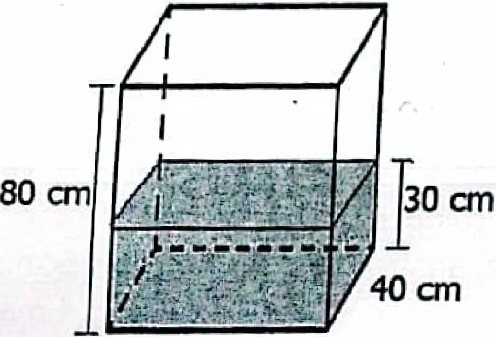

**50 cm**

(a) What is the volume of the water in the tank? **(3 marks)**

(b) How many litres of water are needed to fill the tank? **(3 marks)**

25. a) Mutegaya and Mutambi can sweep the compound in 3 minutes. Mutambi and Mukyasi can sweep that compound in 4 minutes, while Mukyasi alone can sweep the same compound in 6 minutes. How long shall it take Mutegaya to sweep that compound if he worked at the same rate? (4 marks)

26. Using a ruler, a pencil and a pair or compasses, construct a parallelogram KLMN where KL = 8cm, angle KLM=1200 and LM = 5cm. **(4 marks)**

Measure line MK

27. Three traders **A, B** and **C** contributed money to start a business in the ratio of 1:2:5 respectively. If **A** and **B** contributed sh.120,000 less than **C**,

1. What was their total contribution? **(3 marks)**

b) Express C’s contribution as a percentage of their total contribution. **(2 marks)**

28. Alice is 18 years older than Sonia. In 10 years’ time, Sonia will be a half of Alice’s age.

(a) How old is Sonia now? (3 marks)

(b) How old shall Alice be then? **(2 marks)**

29. The table below shows the items bought by Anita from a supermarket.

Use it to answer the questions that follow.

|  |  |  |  |
| --- | --- | --- | --- |
| **Item** | **Quantity** | **Unit cost** | **Amount** |
| Rice |  | Sh.2,600 | Sh.23,400 |
| Sugar | 5kg | Sh.4,500 |  |
| Soap | 2 bars |  | Sh.12,000 |
| Bread | 2 loaves |  |  |
| **Total expenditure** | | | **Sh.71,900** |

1. Complete the above table with the correct information. (5 marks)
2. If he was given a discount of sh.1900, how much money did he pay? (1 mark)

30. Bruno moved from town P to Q at 25km/hr for 2 hours. He rested at town Q for one hour before continuing to town R at 30km/hr for 2 hours.

1. How far is town Q from town P? **(2 marks)**

(b) Calculate his average speed for the whole journey. **(3 marks)**

31. a) Find the area of a rhombus PQRS with diagonals PR = 16cm and QS = 12cm.

(b) Work out the area of the shape below. **(3 marks)**

**20 cm**

**13 cm**

**h**

**25 cm**

32. On Butiki’s farm, there are 15 cows, 12 goats and 9 sheep. Using a radius of 3cm, construct a pie-chart and represent the above information. **(5 marks)**

**END**

**GOOD LUCK**